**MODULE 3 -**

**Two Dimensional Geometric Transformations.**

changes in orientations, size, and shape

Basic geometric transformations are:

1. Translation,

We translate a 2D point by adding translation distances, tx and ty, to the original coordinate position (x,y): x' = x + tx, y' = y + ty

2. Rotation

Rotation About the Origin-

To rotate an object about the origin (0,0), we specify the rotation angle ‘x’

for positive, counter-clockwise rotation.

for negative, clockwise rotation.

General Pivot-Point Rotation

We first translate the object to the origin, then we apply the rotation about the origin and translate it back to its original position.

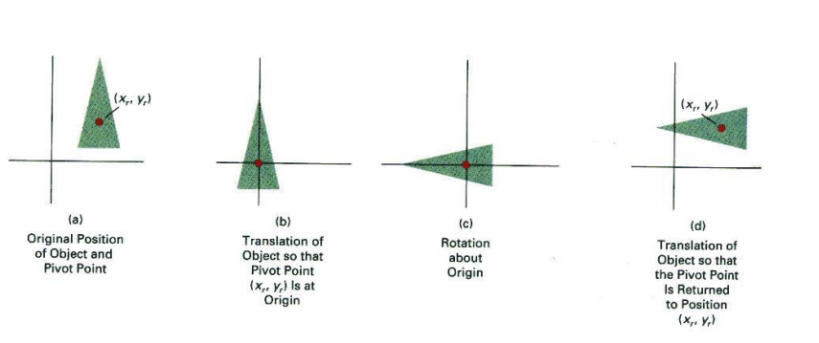

3. Scaling.

Scaling With Respect to the Origin-

We scale a 2D object with respect to the origin by setting the scaling factors sx and sy,

which are multiplied to the original vertex coordinate positions (x,y):

x' = x * sx, y' = y * sy.

General Fixed point Scaling / Composite Translation

Similar to General Pivot point rotation, but scaling is done. The object is enlarged.

Other transformations:

4. Reflection

It is a transformation that produces a mirror image of an object.

The mirror image can be either about the x-axis or the y-axis.

The object is rotated by180°.

5. Shear

It is a transformation that changes the shape of the object.

In X-direction, Horizontal shearing.

In -direction, Vertical Shearing.

---------------------------------------------------

MODULE 4 - Two-Dimensional Viewing and Clipping.

A Window is a rectangular region in the world coordinate system

A Viewport is the area of the screen on which a window is mapped

[where it is to be displayed]

An area on the display device to which the window is mapped is ViewPort.

Points and lines which are outside the window are "cut off" from view. This process of "cutting off" parts of the image of the world is called Clipping.

**Cohen-Sutherland Line Clipping**

2 trivial cases

We divide the area into 9 regions with

Center is the clipping window

Every area has a bit code (top, bottom )

If both endpoints are in the clipping window,

Both outside (AND operation)

Partially outside (Algorithm)

**Disadv-**

1. Clipping window should be rectangular  
2. If endpoints are diagonally opposite, the AND condition returns zero.

**Liang-Barsky Line Clipping / Cyrus-Beck**

We use line parametric equations   
and solve 4 inequalities.   
It overcomes the limitations of Cohen Sutherland

**Sutherland - Hodgman Polygon Clipping**

The Sutherland - Hodgman algorithm performs a clipping of a polygon against each window edge in turn. It accepts an ordered sequence of vertices v1, v2, v3, ..., vn and puts out a set of vertices defining the clipped polygon.

Disadv-

1. This algorithm does not work if the clip window is not convex.

2. If the polygon is not also convex, there may be some dangling edges.

MODULE 5 - Three Dimensional Geometric Transformations, Curves and Fractal Generation

MODULE 6 - Visible Surface Detection and Animation.